Criminal Evidences Management System using Blockchain

In the existing system all crime and evidence details were managing in single centralized server whose database can easily tamper by database administrator to alter evidence details and there is no tool exists to detect such database alteration. In any crime evidence are the only source to capture correct culprit but alteration of evidences make culprit to easily play with the law. Culprit can bribe database administrator to tamper evidence database.

To combat against such database tamper we are employing Blockchain technology to manage evidences. Blockchain has inbuilt support for decentralized (data will be saved in Blocks at multiple nodes), secured and tamper proof storage. Blockchain sore data as block/transaction and associate each block with unique hash code and this hash code will get verify for each subsequent block storage, if data alter at any node then it will result into hash code mismatch and data tamper will get detected. This verification process of Blockchain make it secured and tamper proof data storage.

Blockchain can store and retrieve data using Smart Contracts which can be designed using Solidity programming. This contract contains functions which can be called using any programming language to store or retrieve data from Blockchain. In propose work to manage crime evidence details we have designed following contract.

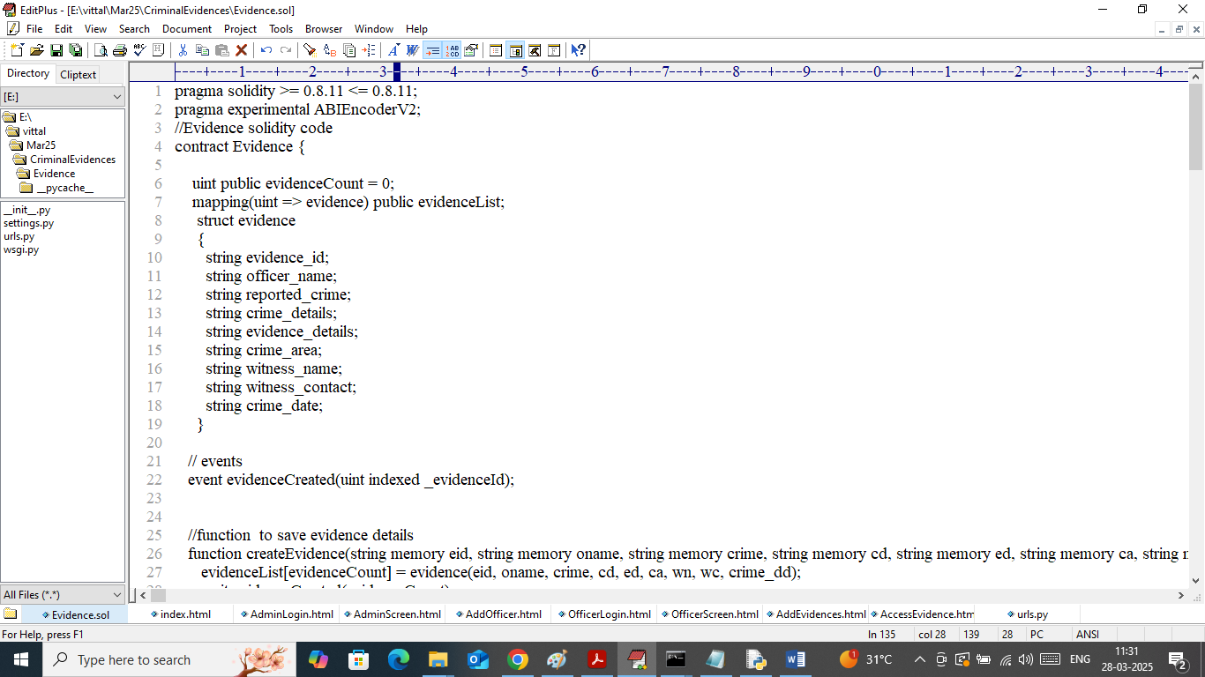

In above contract we have defined functions to manage evidence details and above contract need to deployed in Blockchain Ethereum using below steps

1. First go inside ‘hello-eth/node-modules/bin’ folder and then look and double click on ‘runBlockchain.bat’ file to get below page
2. 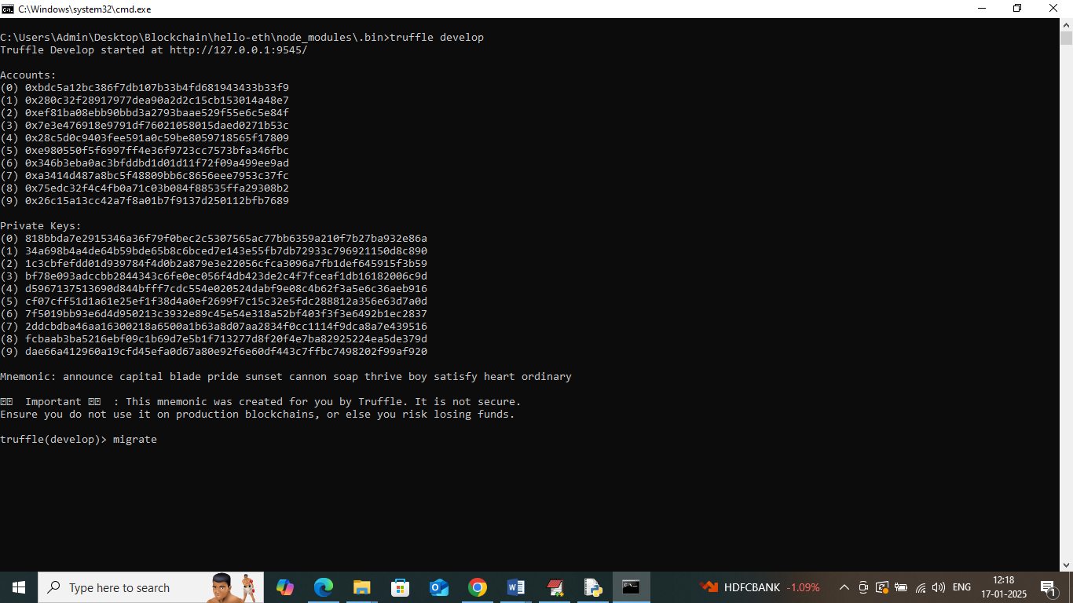
3. In above screen Ethereum started with default account and private keys and now type command as ‘migrate’ and then press enter key to deploy contract and get below page
4. 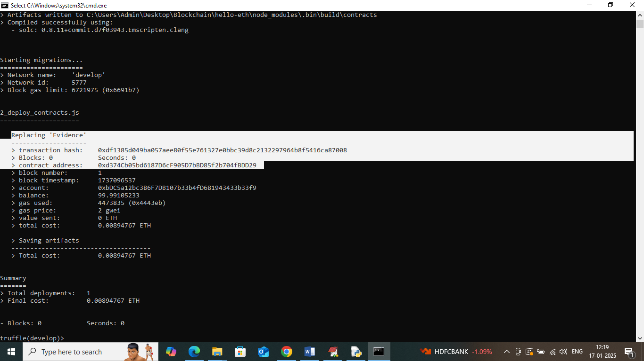
5. In above screen in white colour text can see “evidence” contract deployed and got contract address also and this address need to specify in python programming to call Blockchain contract functions to save and get data. in below screen showing python code calling contract using address
6. 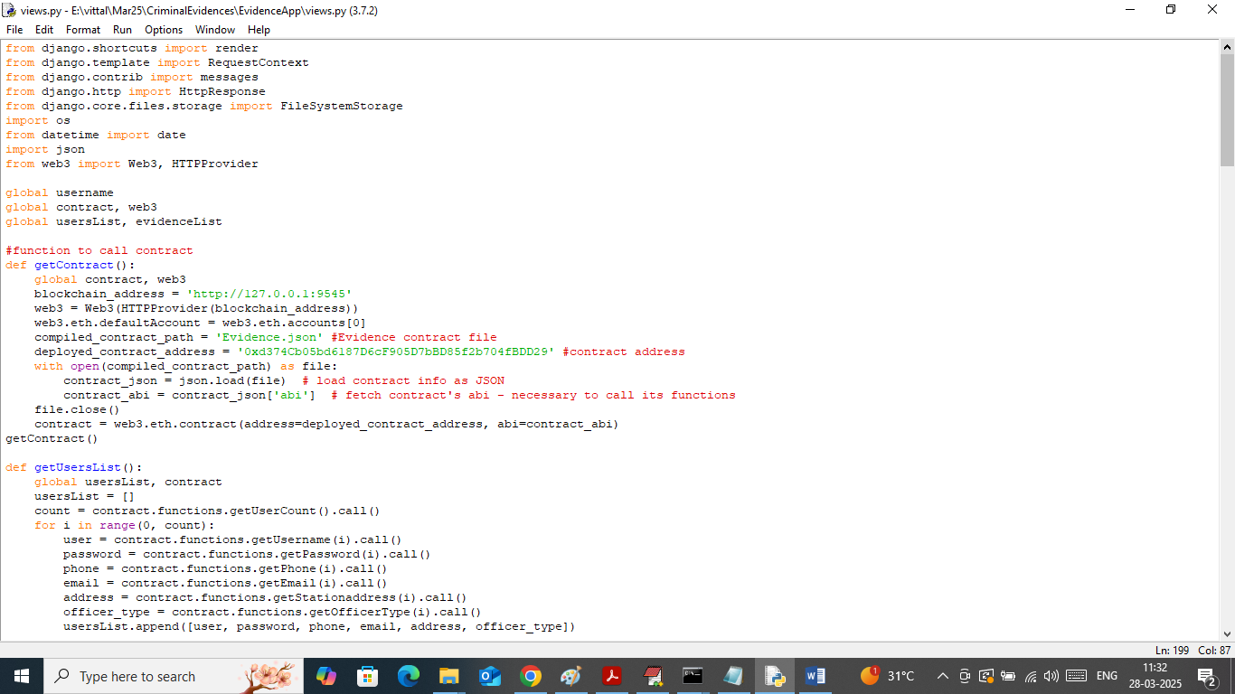
7. In above screen read red colour comments to know about contract calling using contract address. In above black screen we have deployed contract and running successfully and let it run till you execute code.

Modules Information

To implement this project we have designed following modules

1. Admin Login: police department admin can login to system using username and password as ‘admin and admin’.
2. Add Officer Details: after login admin will use this module to add officer and police station details to Blockchain. Admin will issue login details to all officers such as Forensic expert, enforcement officers etc.
3. View Officer: using this module admin can view list of available officers posted in different police station address.
4. View Evidence: admin can view list of evidences and crime added by different officers
5. Officer Login: any area officer can login to system using login details given by admin
6. Add New Evidences: using this module officer will record all crime and evidence details to Blockchain
7. Access Evidences: using this module officer can access crime and evidence details saved in Blockchain.

SCREEN SHOTS

To run project double click on ‘run.bat’ file to start python server and get below page

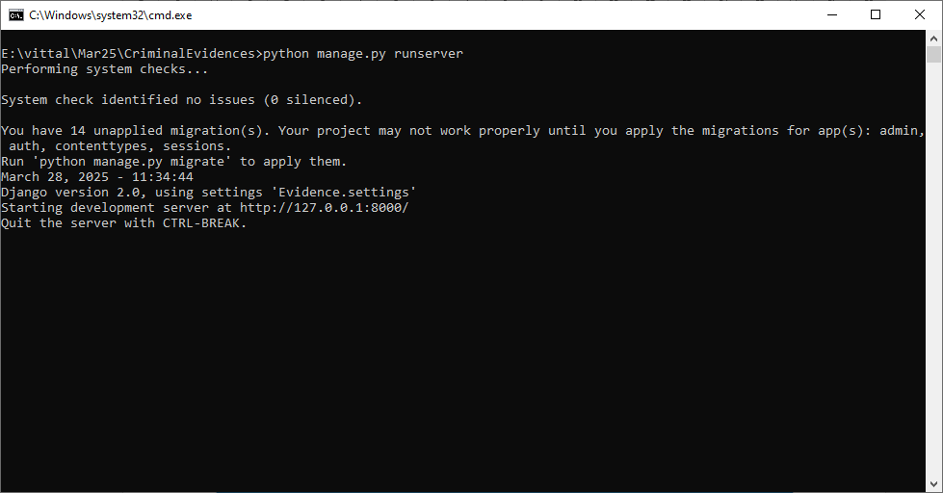

In above screen python server started and now open browser and enter URL as <http://127.0.0.1:8000/index.html> and then press enter key to get below page

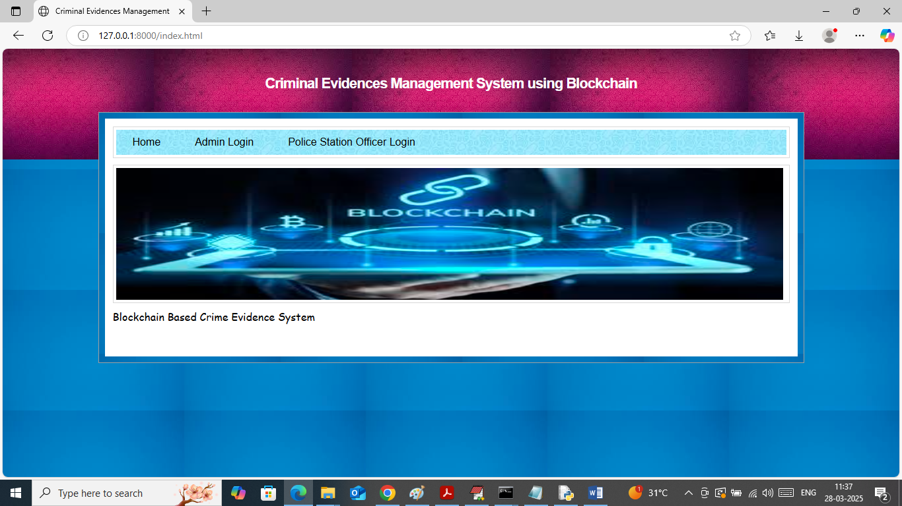

In above screen click on ‘Admin Login’ link to get below page

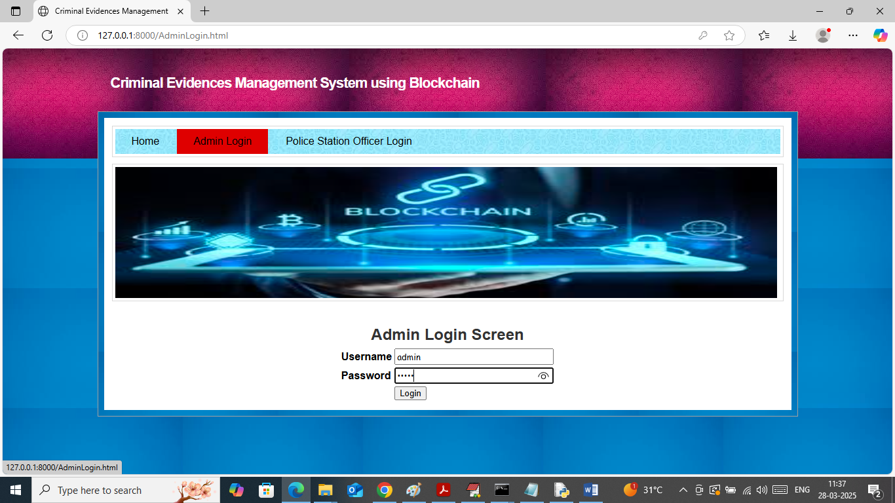

In above screen admin is login and after login will get below page

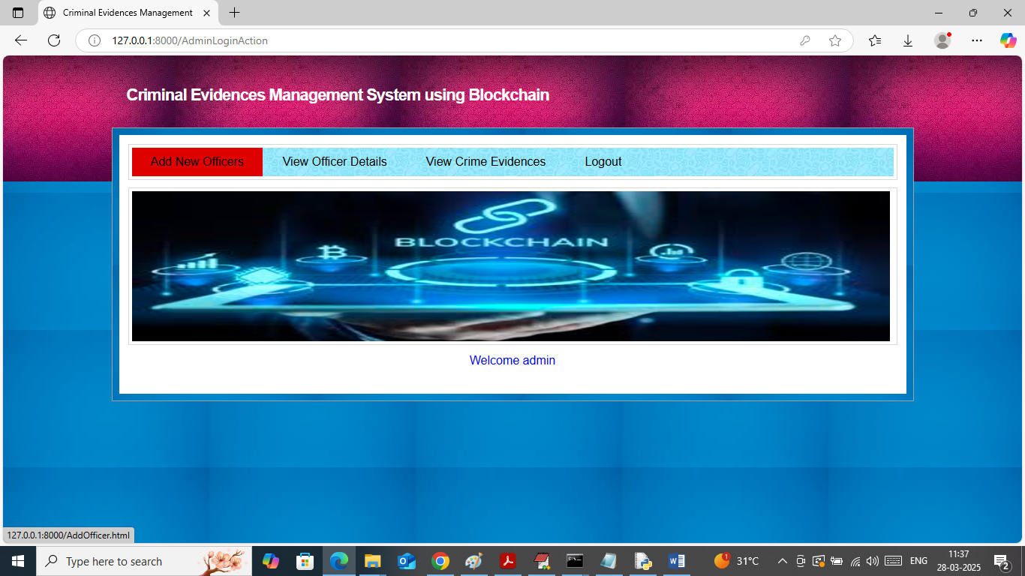

In above screen admin can click on ‘Add New Officer’ link to get below page

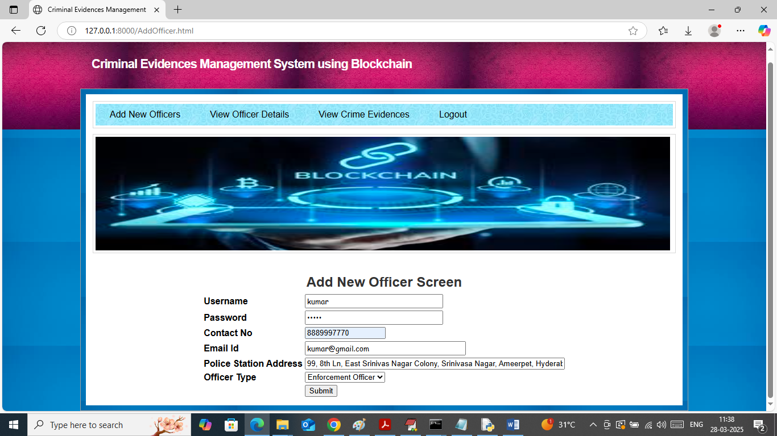

In above screen admin adding details of new officer and then press button to save data in Blockchain and then will get below page

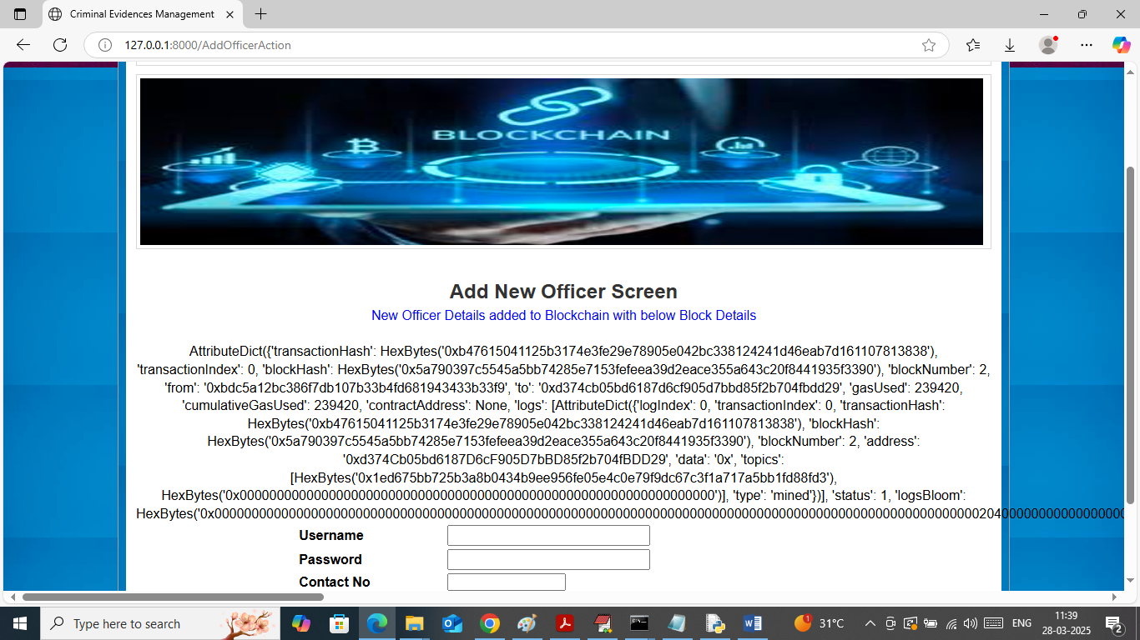

In above screen can see Officer Details added to Blockchain and then in Black colour text displaying all log details obtained from Blockchain which contains details like Block No, transaction no, transaction hash code and many other details. Similarly admin can add any number of officer details and now click on ‘View Officer’ link to view list of available officers

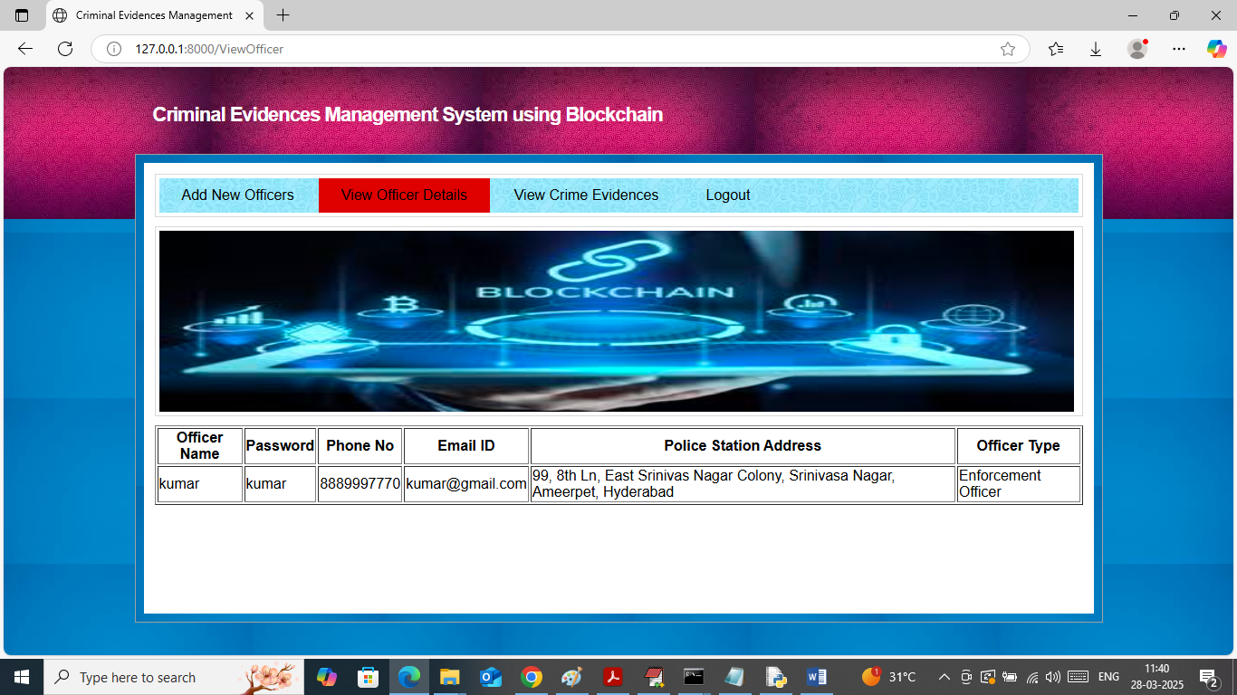

In above screen admin can view list of available officers and now logout and login as officer to add investigation details

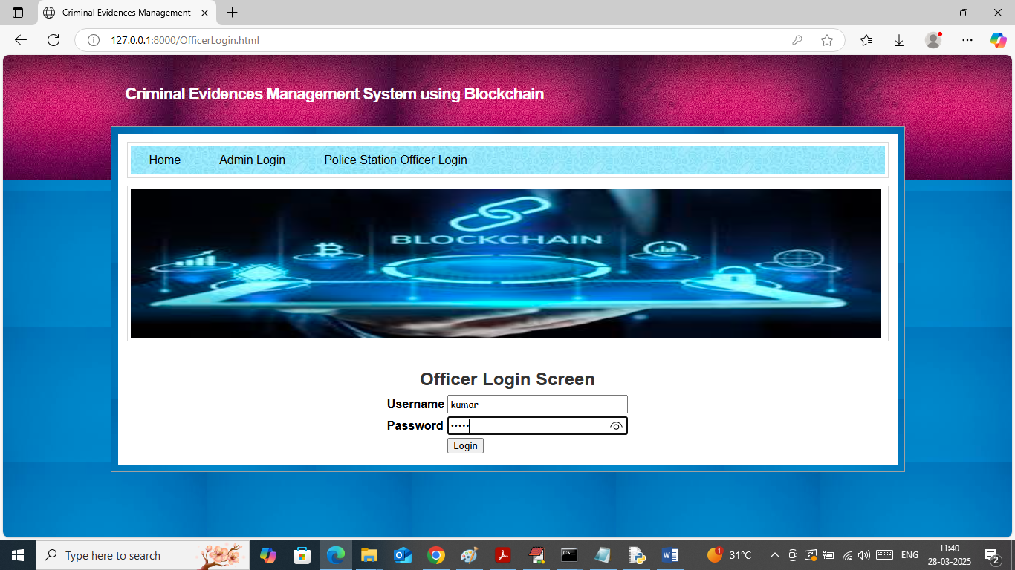

In above screen officer is login and after login will get below page

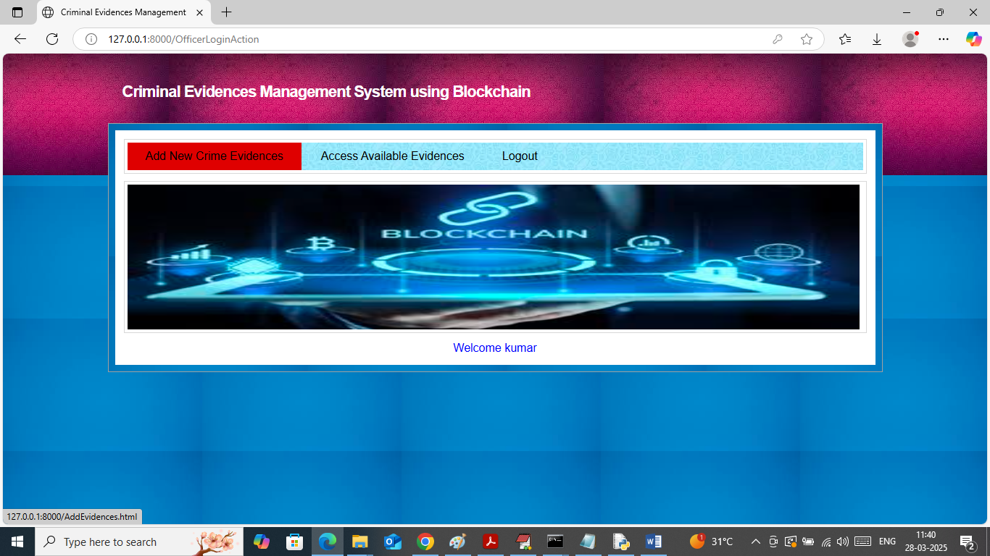

In above screen officer can click on ‘Add New Crime Evidence’ link to get below page

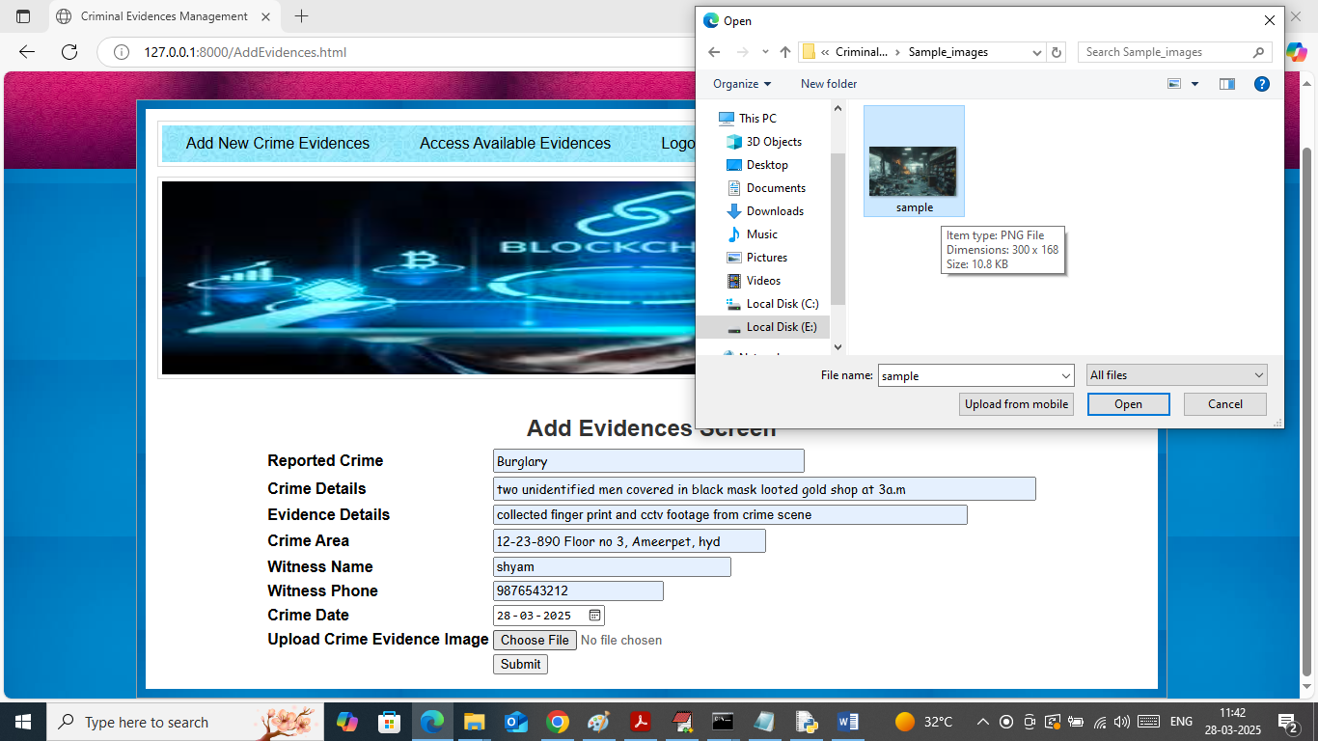

In above screen adding all crime and evidence details along with image and then press button to save data in Blockchain and then will get below page

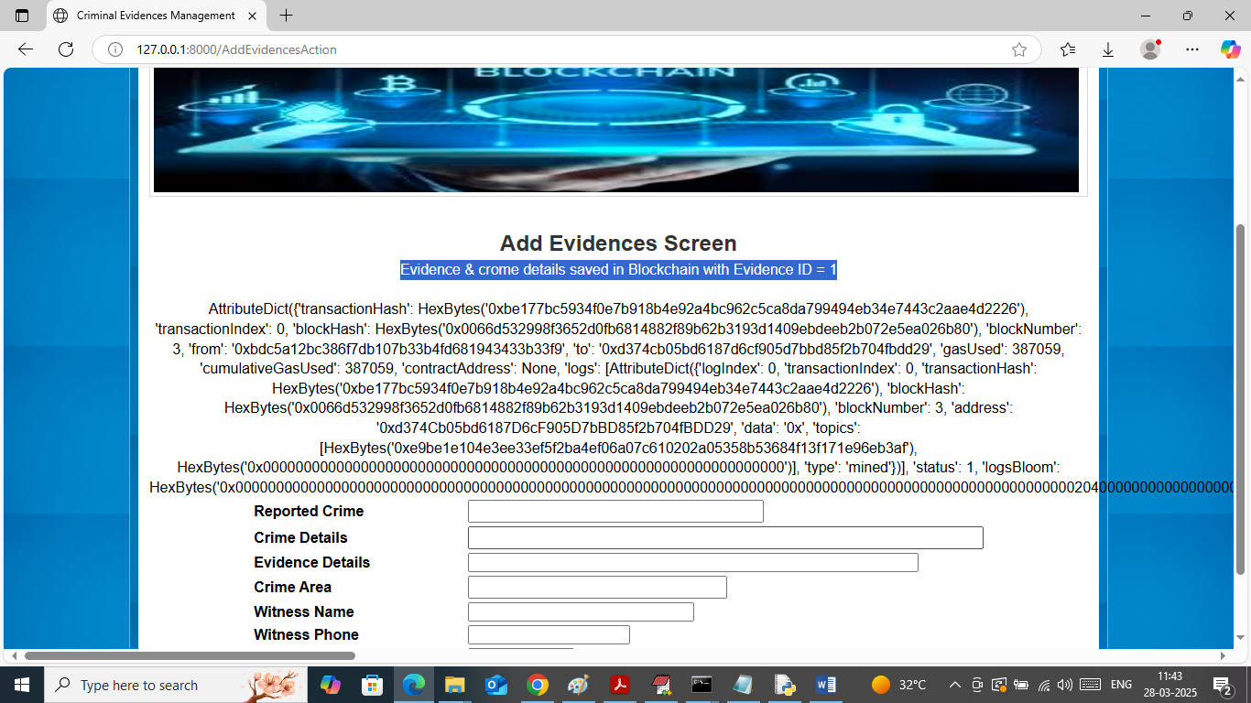

In above screen can see crime and evidence details added to Blockchain and can see details of log which contains block no and other information. Now click on ‘Access Evidence’ link to get below page

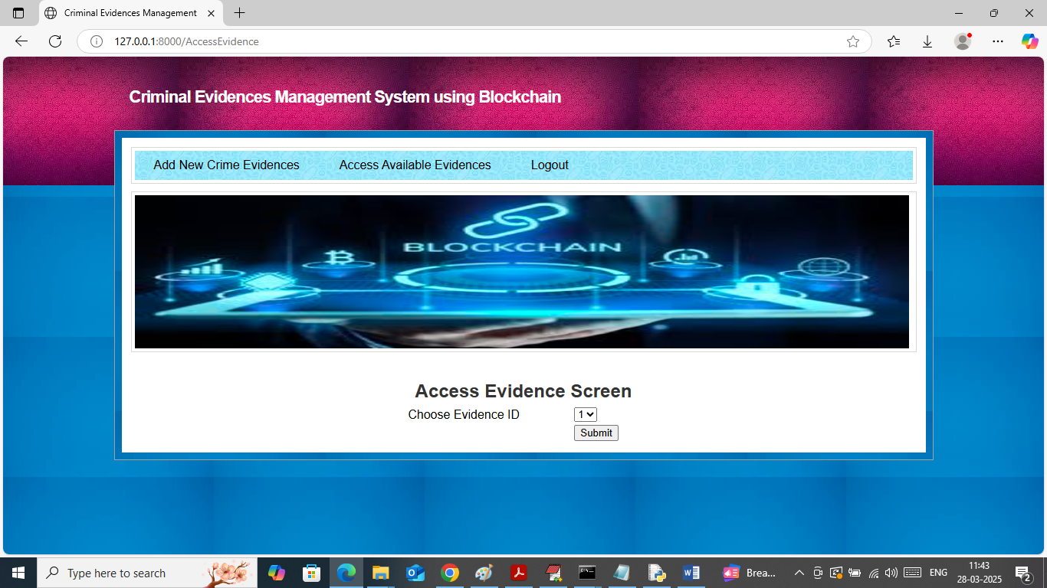

In above screen officer can select evidence Id and then press button to get all details from Blockchain

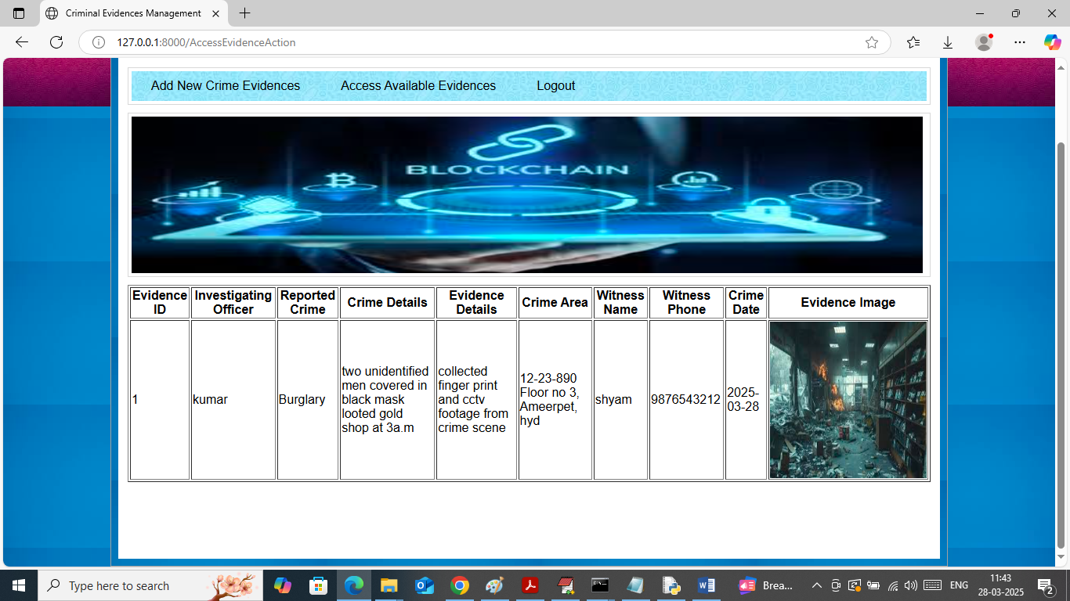

In above screen officer can view all evidence and crime details obtained from Blockchain. Now logout and login as admin to access all recorded criminal evidences

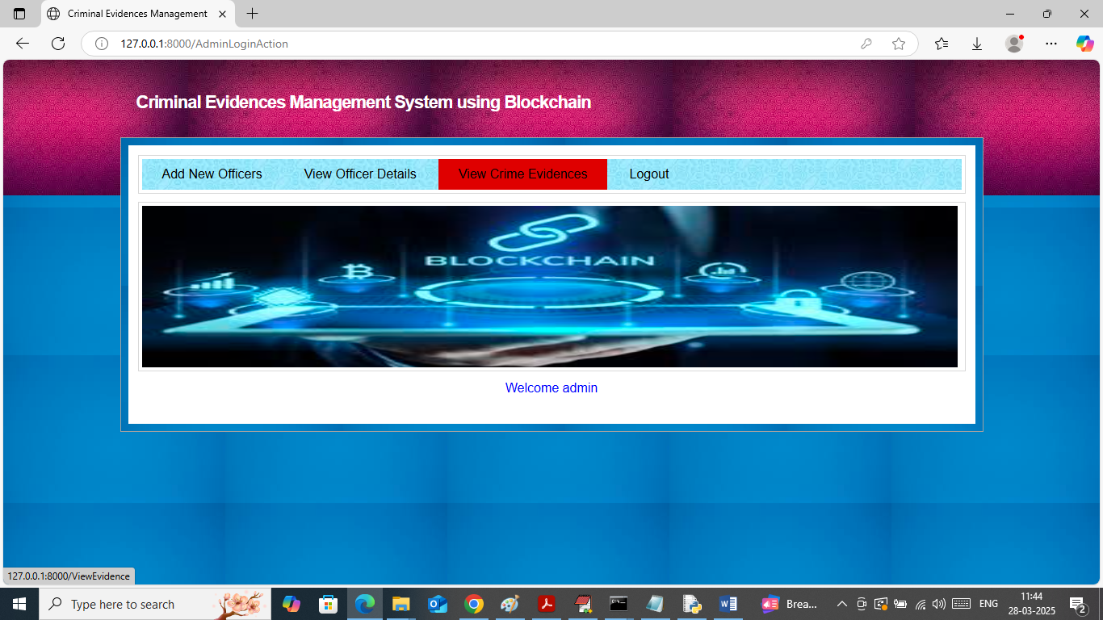

In above screen admin can click on ‘View Crime Evidences’ link to get below page

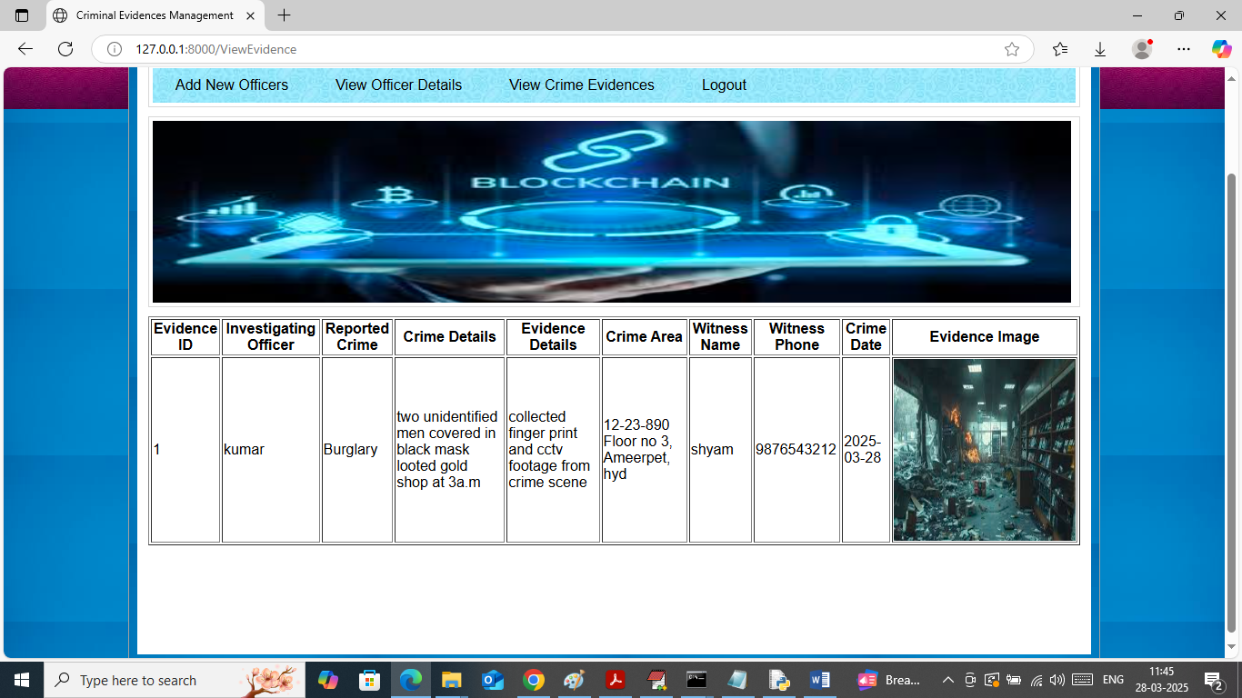

In above screen admin can view list of added criminal evidences details from Blockchain

Similarly by following above screens you can manage all crime and evidence details in Blockchain.